

**SCHOOL OF COMPUTER SCIENCE AND ENGINEERING**

A MINI-PROJECT REPORT

ON

“**SENTIMENT ANALYSIS ON E-COMMERCE”**

Submitted in partial fulfilment of the requirements for the award of the

Degree of

**BACHELOR OF TECHNOLOGY**

**IN**

**COMPUTER SCIENCE AND ENGINEERING**

Submitted by

VISHAL R20EF440

HARSHTHA S R R20EF406

SUPRIYA Y S R20EF437

PRADHUMNA R20EF420

Under the guidance of

**Prof.Nayana R**

Designation, School of CSE

**REVA University**

Rukmini Knowledge Park, Kattigenahalli, Yelahanka, Bengaluru-560064

[www.reva.edu.in](http://www.reva.edu.in)



**DECLARATION**

We, **VISHAL, HARSHTHA S R, SUPRIYA Y S and PRADHUMNA** students of B.Tech, VI Semester, School of Computer Science and Engineering, REVA University declare that the Mini-Project Report entitled **“SENTIMENT ANALYSIS ON E-COMMERECE”** done by us under the guidance of **Prof.Nayana R**, **Assistant Professor**, School of Computer Science and Engineering, REVA University.

We are submitting the Mini-Project Report in partial fulfilment of the requirements for the award of the degree of Bachelor of Technology in Computer Science and Engineering by the REVA University, Bengaluru during the academic year 2022-23.

We further declare that the Mini-Project or any part of it has not been submitted for award of any other Degree of REVA University or any other University / Institution.

1. VISHAL R20EF440
2. HARSHITHA S R R20EF406
3. SUPRIYA Y S R20EF437
4. PRADHUMNA R20EF420



**SCHOOL OF COMPUTER SCIENCE AND ENGINEERING**

**CERTIFICATE**

This is to certify that the Mini-Project entitled **“PROJECT TITLE”** carried out under my guidance for **VISHAL, HARSHTHA S R, SUPRIYA Y S and PRADHUMNA** **Team members name and SRN** **R20EF440,R20EF406,R20EF437,R20EF420** Bonafede students of REVA University during the academic year 2022-23. The above-mentioned students are submitting the Mini-Project report in partial fulfilment for the award of Bachelor of Technology in Computer Science and Engineeringduring the academic year 2022-23**.** The Mini-Project report has been approved as it satisfies the academic requirements in respect of Mini-Project work prescribed for the said degree.

**Signature with date Signature with date**

**Guide Deputy Director**

**Name of the Examiner Signature with Date**

1.

2.

## **ACKNOWLEDGEMENT**

## We would like to express our deepest gratitude to **Dr. P. Shyama Raju,** Founder Chancellor for providing us the necessary facilities for the successful completion Mini-Project. We would also like to acknowledge **Mr. Umesh Raju**, Pro Chancellor, **Dr. M. Dhanamjaya**, Vice-Chancellor, **Dr. R C Biradar,** Pro Vice-Chancellor and **Dr. N. Ramesh,** Registrar for their constant support and endorsement through invaluable administration.

## In the same breath, we would also like to mention our sincere gratitude to **Dr. Ashwinkumar U. M,** Deputy Director, School of Computer Science and Engineering for his constant support and encouragement. We would like to express our deepest gratitude to **Dr. T. Prasanth**, Mini-Project Coordinator for giving us an opportunity to take up the Mini-Project.

We wish to record my deep sense of gratitude and profound thanks to our guide **Prof.nayana r, assitant professor**, School of Computer Science and Engineering, REVA University for his keen interest, inspiring guidance, constant encouragement with my work during all stages, to bring the Mini-Project report into fruition.

**TABLLE OF CONTENTS**

**DECLARATION** **ii**

**ABSTRACT** **vi**

**INTRODUCTION** **vii**

**OBJECTIVES** **viii**

**LITERATURE REVIEW** ix-x

**CONCLUSION** **xi**

**REFERENCES** **xii**

**ABSTRACT**

## A division of natural language processing called sentiment analysis looks for and extracts subjective information from text. It entails analyzing text data to detect the sentiment of the material, whether it is positive, negative, or neutral. This is done by using machine learning and statistical techniques. Sentiment analysis has several uses, including analyzing customer reviews, forecasting stock market trends, and tracking sentiment on social media. Lexicon-based approaches use lexicons or sentiment dictionaries that have pre-made lists of words and their corresponding polarity in order to assign sentiment ratings to the text. On the other hand, machine learning-based techniques entail training a model on a labelled dataset to discover the patterns and connections between text and sentiment. To increase the precision of sentiment analysis, hybrid methods incorporate both lexicon-based and machine learning-based techniques.Numerous industries, including marketing, politics, customer service, and healthcare, use sentiment analysis. Sentiment analysis, for instance, can be used to track social media sentiment and examine consumer reviews to enhance goods and services. It can also be used to forecast election results and analyze political speeches. Sentiment analysis in healthcare can be used to examine patient comments and pinpoint areas where healthcare services need to be improved.

## **INTRODUCTION**

* Sentiment analysis can be defined as analyzing the positive or negative sentiment of the customer in text. The contextual analysis of identifying information helps businesses understand their customers’ social sentiment by monitoring online conversations.
* As customers express their reviews and thoughts about the brand more openly than ever before, sentiment analysis has become a powerful tool to monitor and understand online conversations. Analyzing customer feedback and reviews automatically through survey responses or social media discussions allows you to learn what makes your customer happy or disappointed. Further, you can use this analysis to tailor your products and services to meet your customer’s needs and make your brand successful.
* Due to the complexity of natural language and the subjectivity of human emotions, sentiment analysis is a difficult process. In response to the same material, different persons may feel various emotions, and the same emotion may be represented using various words or expressions. As a result, complex methodologies are needed for sentiment analysis in order to capture the subtleties of language and the context in which it is used.

**OBJECTIVES**

* By using sentimental analysis, we will get to know about the product. Sentiments like reviews, emojis, rating and also by uploading the product picture.
* This prediction helps the platform to know about the productivity of particular product.
* To study about the customers satisfaction of online shopping.
* This sentimental analysis helps to know which product category has lower review or may be inferior product.
* Detects the emotion of the customers regarding products, services, or the brand.

**LITERATURE SURVEY AND REVIEW**

* Sentiment Analysis using NLP and Machine Learning Techniques on Social Media Data ,published in [2022 2nd International Conference on Advance Computing and Innovative Technologies in Engineering (ICACITE)](https://ieeexplore.ieee.org/xpl/conhome/9823381/proceeding),Published by [M. Kavitha](https://ieeexplore.ieee.org/author/37085349051),[Bharat Bhushan Naib](https://ieeexplore.ieee.org/author/37088439390),[Basetty Mallikarjuna](https://ieeexplore.ieee.org/author/37088930425),[R. Kavitha](https://ieeexplore.ieee.org/author/37089269867); [R. Srinivasan](https://ieeexplore.ieee.org/author/37089360215)**.**
* Sentiment analysis in twitter using machine learning techniques , published in [2013 Fourth International Conference on Computing, Communications and Networking Technologies (ICCCNT)](https://ieeexplore.ieee.org/xpl/conhome/6715259/proceeding), published by,[M S Neethu](https://ieeexplore.ieee.org/author/37087357745) and [R Rajasree](https://ieeexplore.ieee.org/author/37085750700).
* Sentiment Analysis on Product Reviews Using Machine Learning Techniques ,published in 2019, published by, Rajkumar S. Jagdale, Vishal S. Shirsat and Sachin N. Deshmukh.
* Sentiment Analysis of Amazon Products Using Ensemble Machine Learning Algorithm ,published in February 5, 2019 , published by Jayakumar Sadhasivam and Ramesh Babu Kalivaradhan.
* Dataset Source: Kaggle  [https://www.kaggle.com/](mailto:https://www.kaggle.com/)

## Result:-

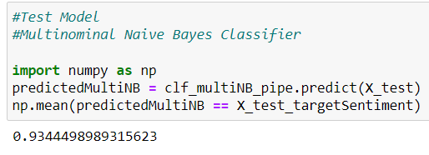

Fig.1. Finding Accuracy Using Naïve Bayes Classifier

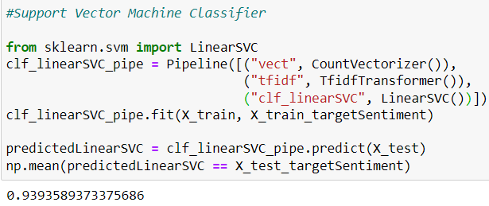

Fig.2. Finding Accuracy Using Support Vector Machine Classifier

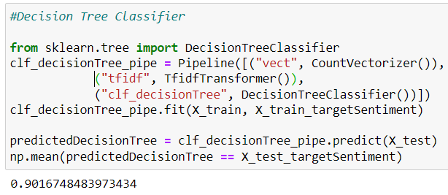

Fig.3. Finding Accuracy Using Decision Tree Classifier

Fig.4. Finding Accuracy Using Logistic Regression

* By Observing above accuracy of predictions such as Multinominal Naive Bayes Classifier , Support Vector Machine Classifier, Decision Tree Classifier and Logistic Regression we can conclude that among all those prediction models Support Vector Machine giving the highest accuracy.
* So by using Support Vector Machine Algorithm we will get the maximum accuracy of predicting the Reviews.

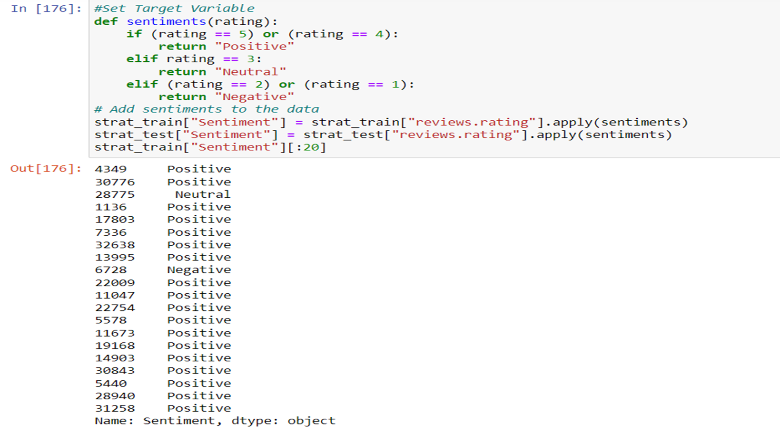

Fig.5. Setting Target Variables for Ratings to know either a rating is Positive,

Negative or Neutral.

**CONCLUSION**

In conclusion, sentiment analysis on product reviews is an important area of exploration with significant implicit operations for businesses and associations. still, it presents unique challenges that bear specific results, similar as the objectification of sphere-specific sentiment dictionaries, counting for the influence of product attributes, using stoner demographics, addressing fake reviews, developing ways for relative sentiment analysis, and incorporating visual analysis. By addressing these challenges and incorporating these results, sentiment analysis on product reviews can give more accurate and practicable perceptivity, helping companies and associations make data- driven opinions to ameliorate their products and services. As similar, sentiment analysis on product reviews represents an instigative area of exploration with significant eventuality for unborn advancements and operations.

**REFERENCES**

* Sentiment Analysis using NLP and Machine Learning Techniques on Social Media Data ,published in [2022 2nd International Conference on Advance Computing and Innovative Technologies in Engineering (ICACITE)](https://ieeexplore.ieee.org/xpl/conhome/9823381/proceeding),Published by [M. Kavitha](https://ieeexplore.ieee.org/author/37085349051),[Bharat Bhushan Naib](https://ieeexplore.ieee.org/author/37088439390),[Basetty Mallikarjuna](https://ieeexplore.ieee.org/author/37088930425),[R. Kavitha](https://ieeexplore.ieee.org/author/37089269867); [R. Srinivasan](https://ieeexplore.ieee.org/author/37089360215)**.**
* Sentiment analysis in twitter using machine learning techniques , published in [2013 Fourth International Conference on Computing, Communications and Networking Technologies (ICCCNT)](https://ieeexplore.ieee.org/xpl/conhome/6715259/proceeding), published by,[M S Neethu](https://ieeexplore.ieee.org/author/37087357745) and [R Rajasree](https://ieeexplore.ieee.org/author/37085750700).
* Sentiment Analysis on Product Reviews Using Machine Learning Techniques ,published in 2019, published by, Rajkumar S. Jagdale, Vishal S. Shirsat and Sachin N. Deshmukh.
* Sentiment Analysis of Amazon Products Using Ensemble Machine Learning Algorithm ,published in February 5, 2019 , published by Jayakumar Sadhasivam and Ramesh Babu Kalivaradhan.
* Dataset Source: Kaggle  [https://www.kaggle.com/](mailto:https://www.kaggle.com/)